**Assignment-1:** To deploy an application in Tomcat Server using the Build Toll – Maven.

1.Tomcat server installed and running status.

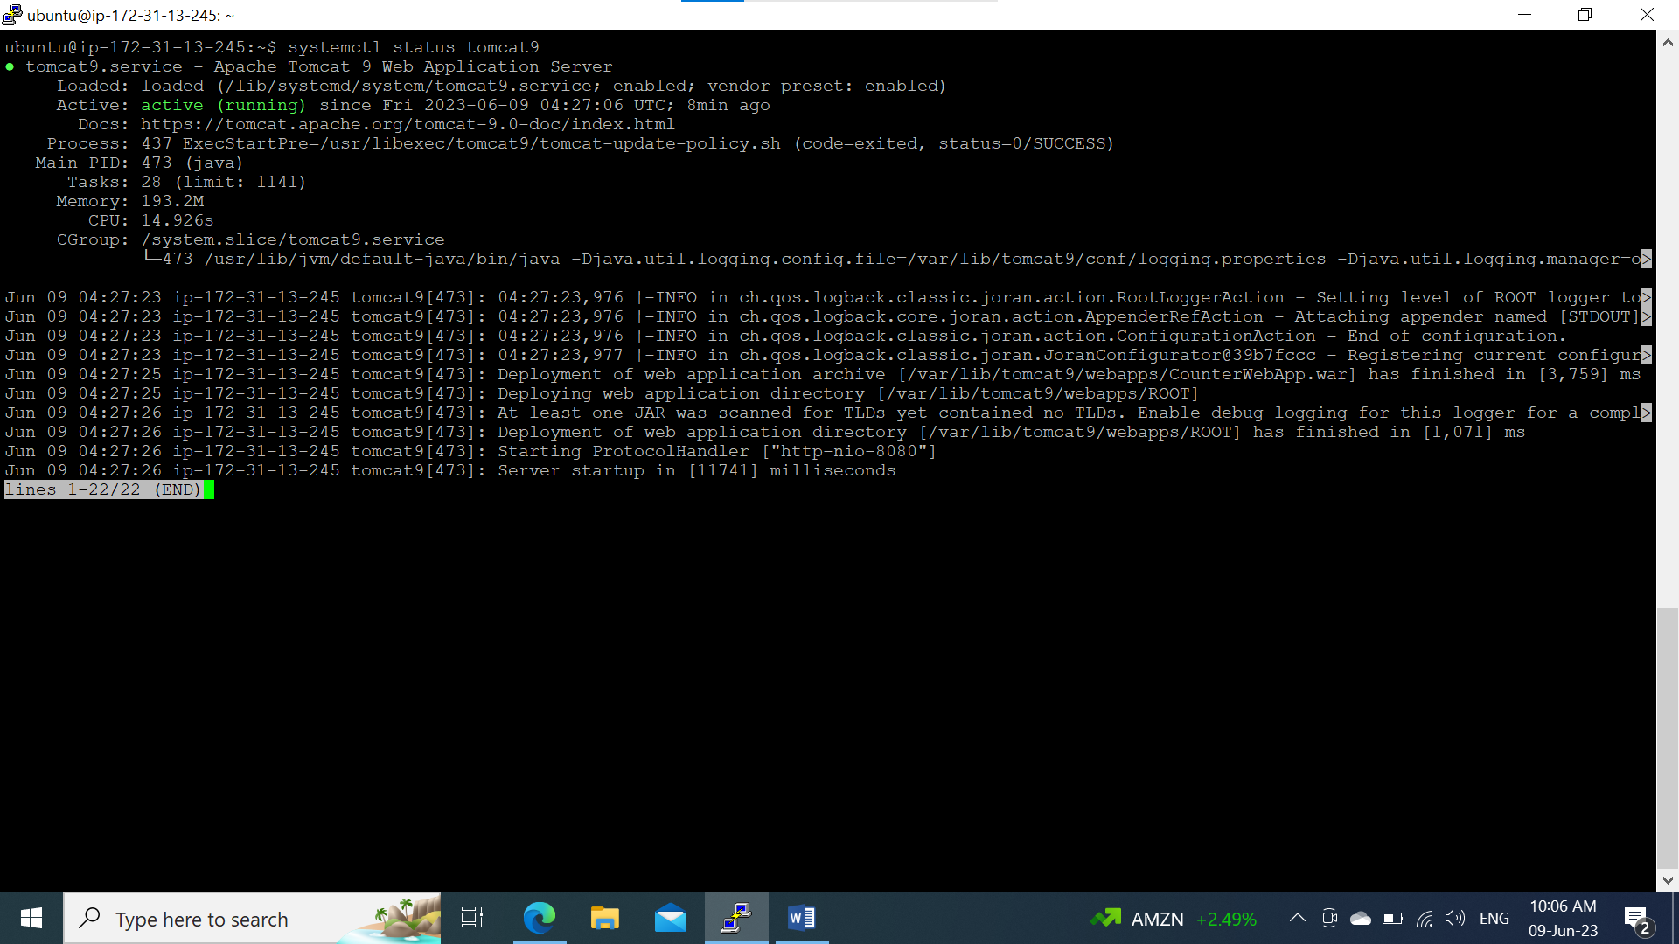

2. Build the package.

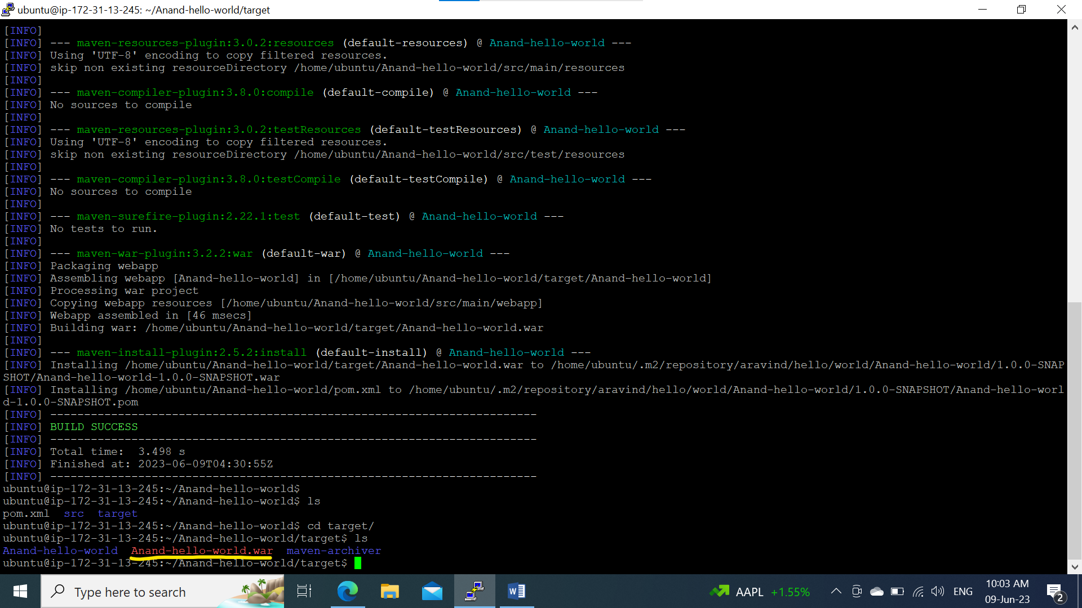

3. Deployed WAR file in Apachi Tomcat Web Server.

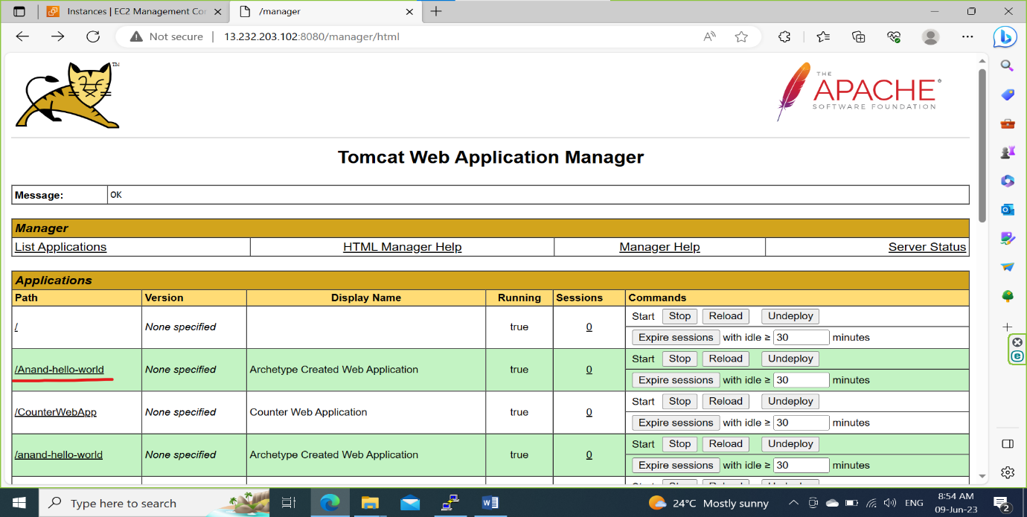

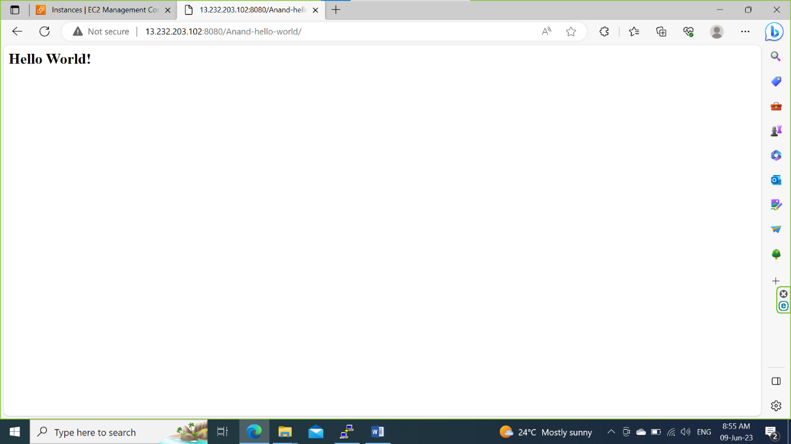

**Assignment-2**: Connect to the Private Server using the Bastion server using NAT Gateway

Step-1: Create a VPC

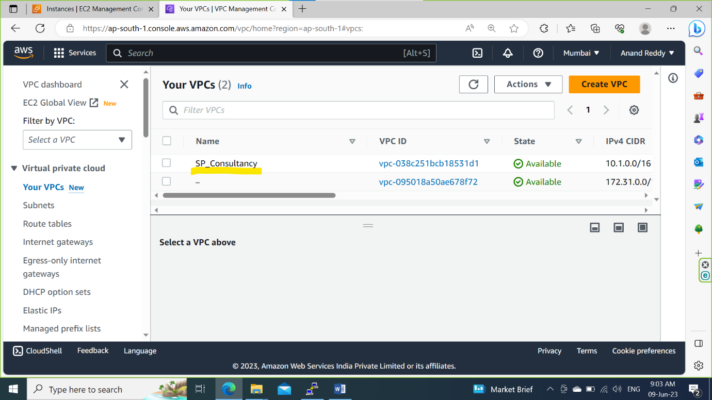

Step-2: Create a Subnets for Both Public and private.

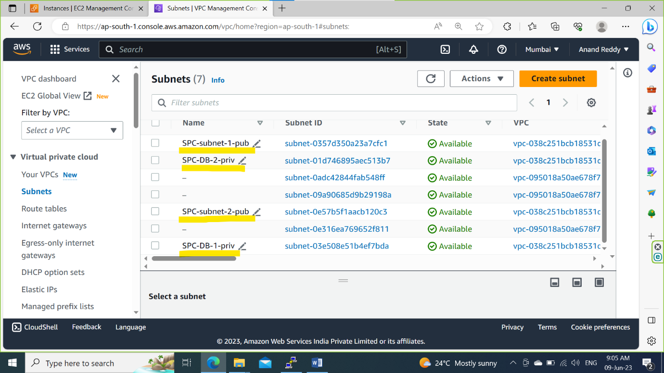

Step-3: Create a Internet Gateway name it as SPC-IGW and attach to the VPC.

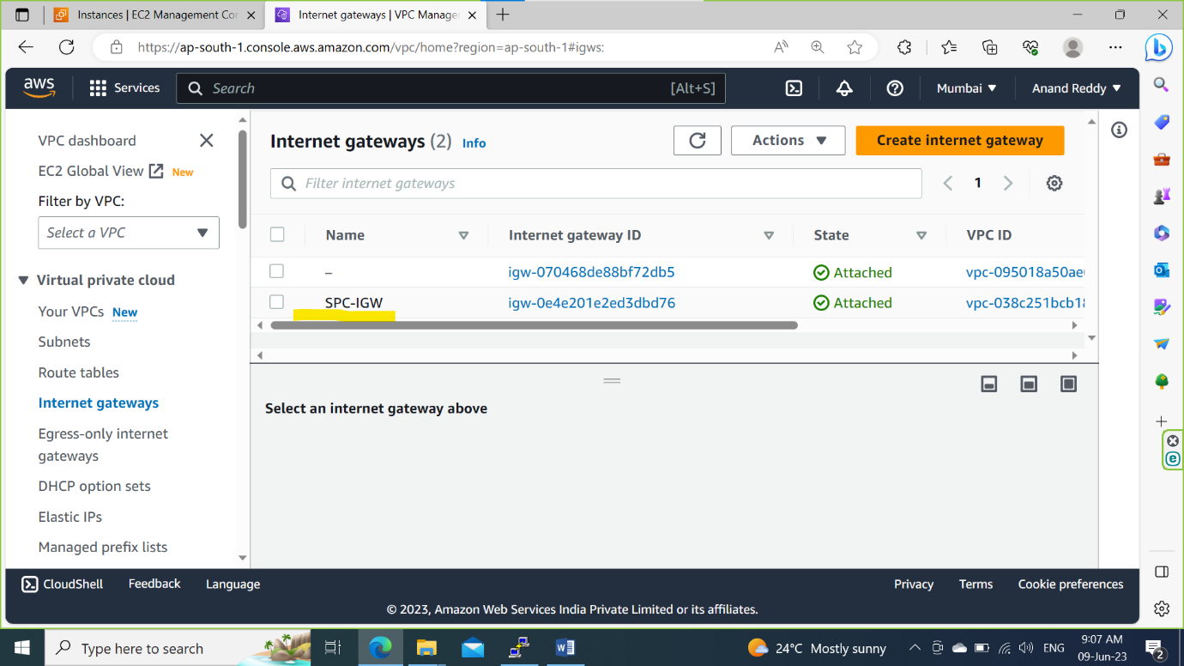

Step-4: Create a routing Table name it as SPC-MAIN-TABLE and attach Public Subnets to it.

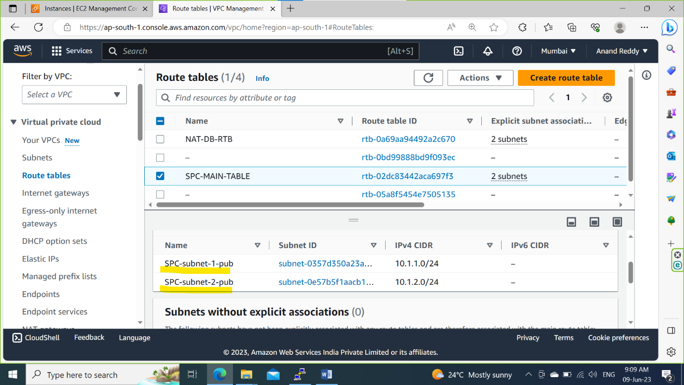

Step-5: Add a new route towards 0.0.0.0/0 through IGW.

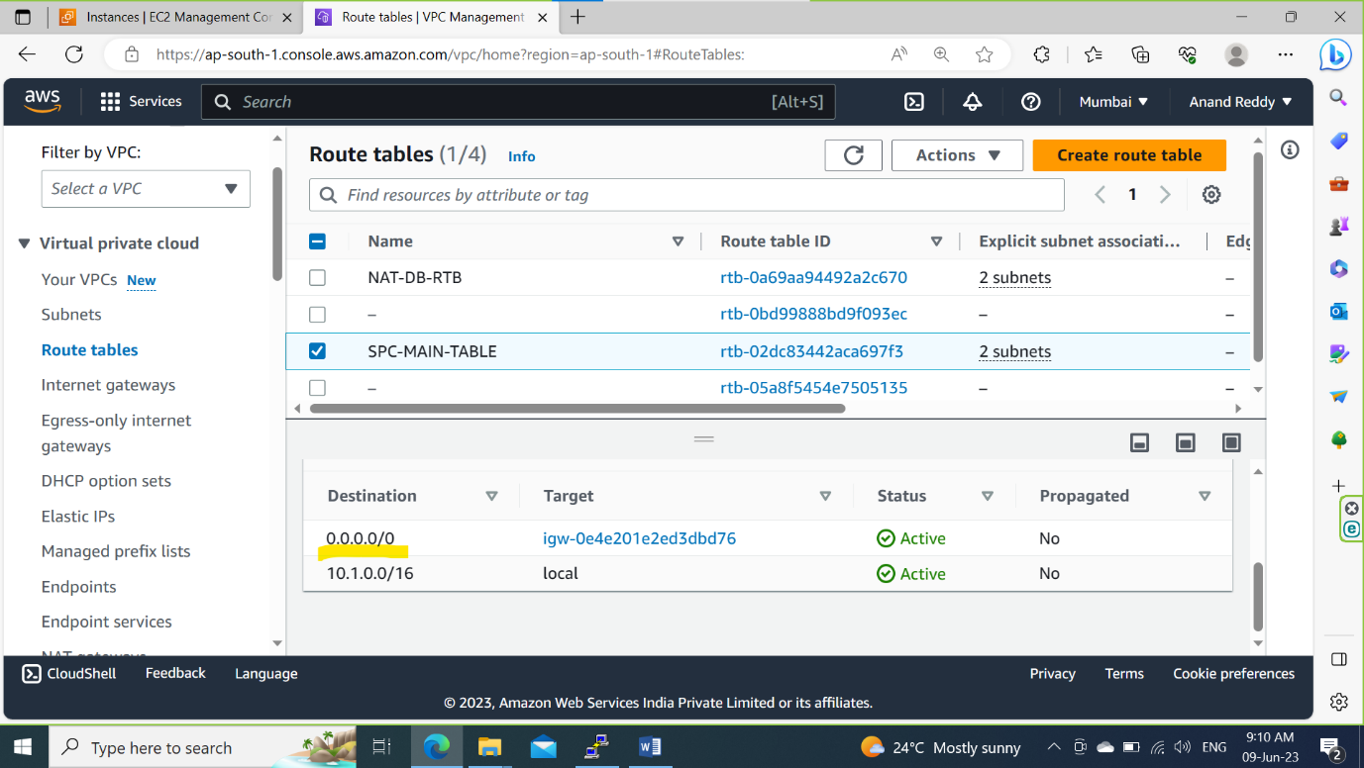

Step-6: Create a NAT Gate and select SPC-subnet1-pub and attach to VPC

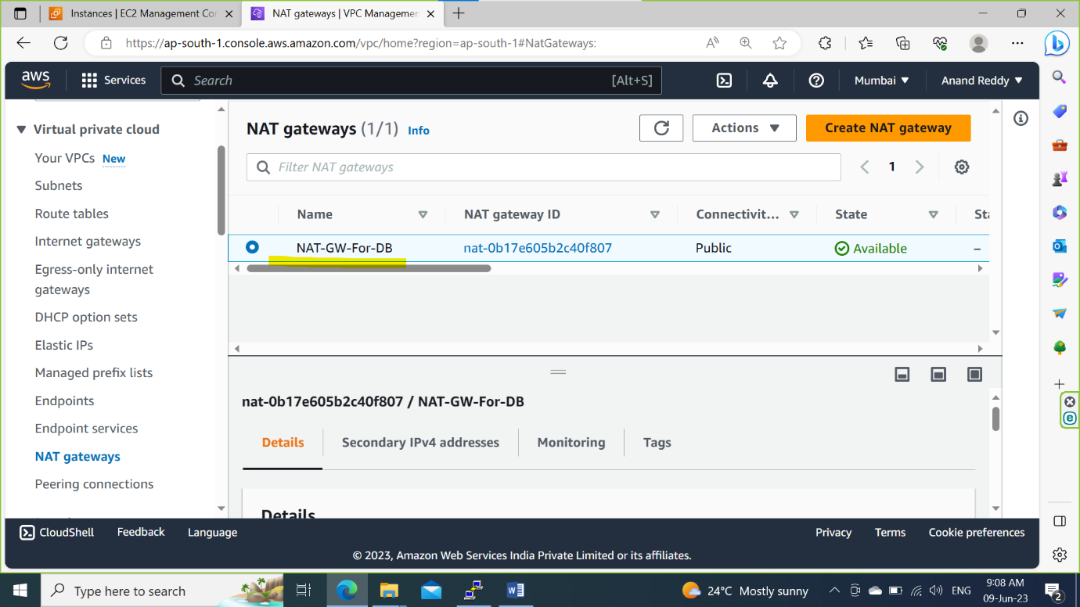

Step-7: Create a route table for NAT and attach private subnets to it.

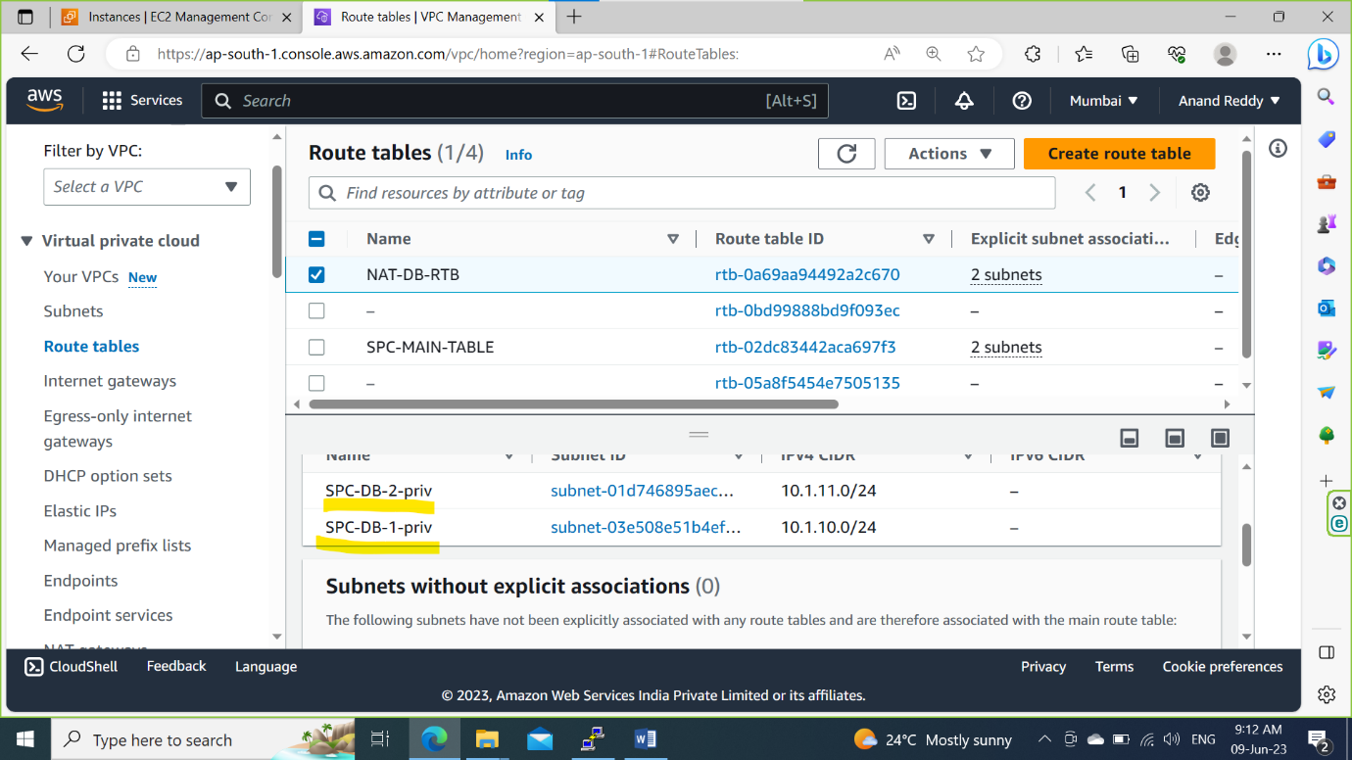

Step-8: Add a new route towards 0.0.0.0/0 through NAT Gateway

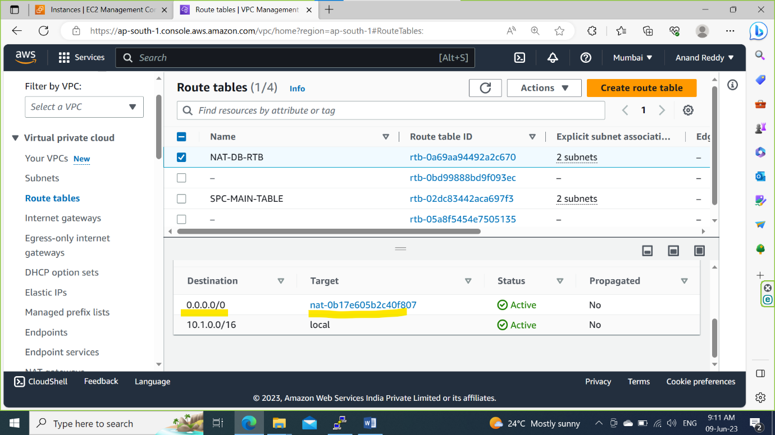

Step-9: Launch Public(Bastion Server) and Private(DB-priv) Server.

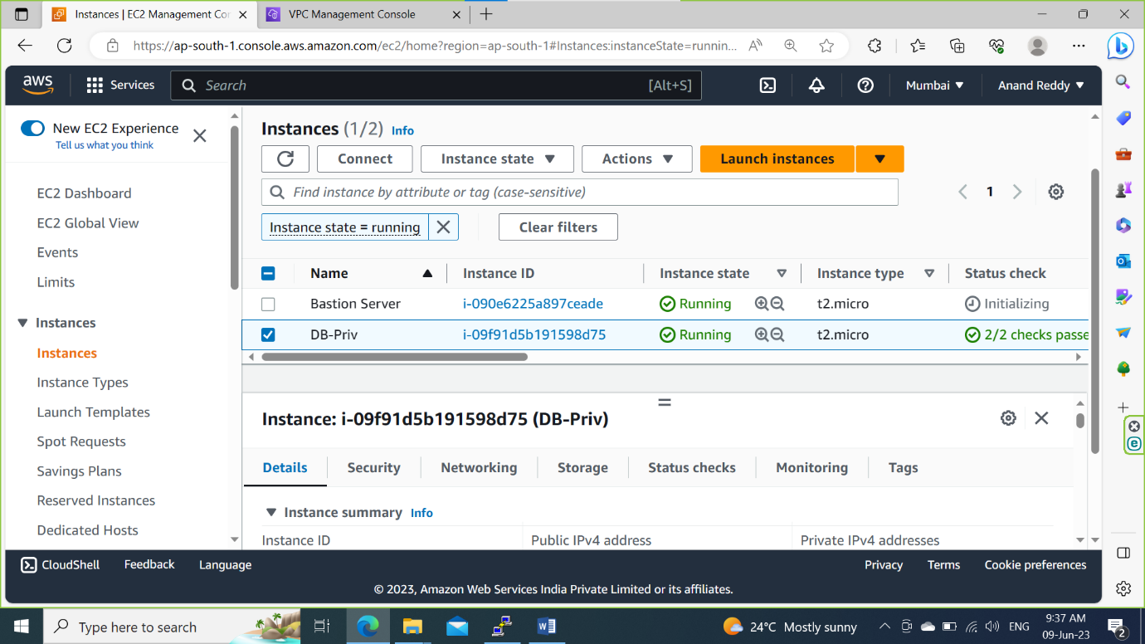

Step-10: Check the DB-priv server is pingable or not

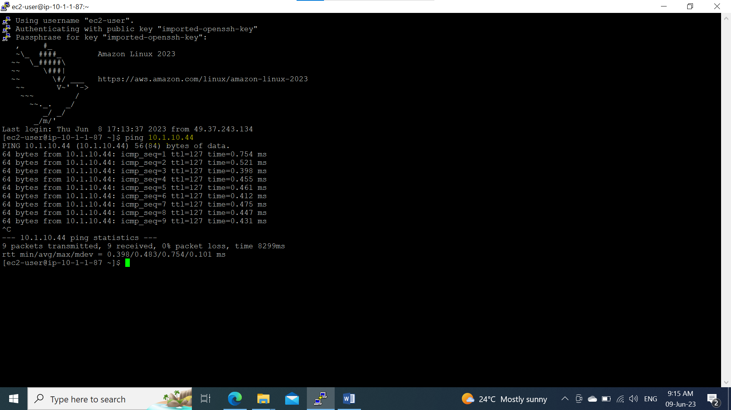

Step-11: Establish a Connection to DB-Server using SSH.

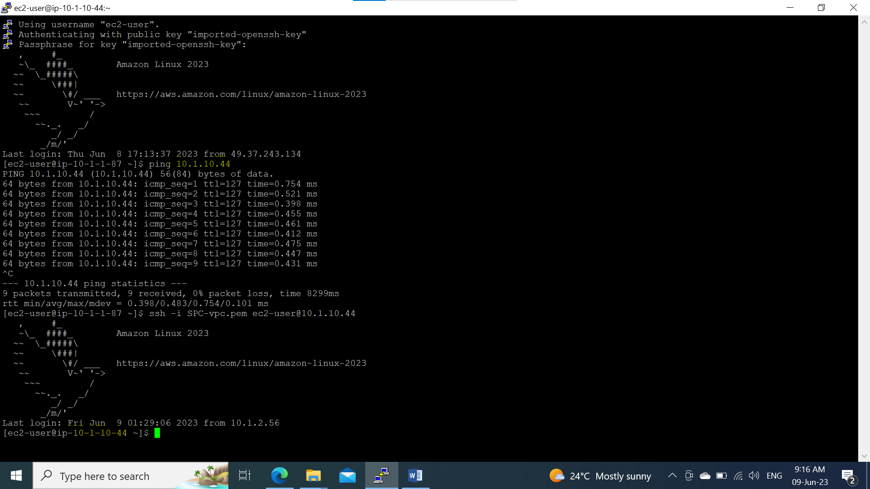

**Assignment-3:** To create a file in Ec2 instance and cp to S3 bucket using AWS CLI

Step 1: Create a new bucket using AWS CLI

Command: **aws s3 mb s3://<bucket_name>**

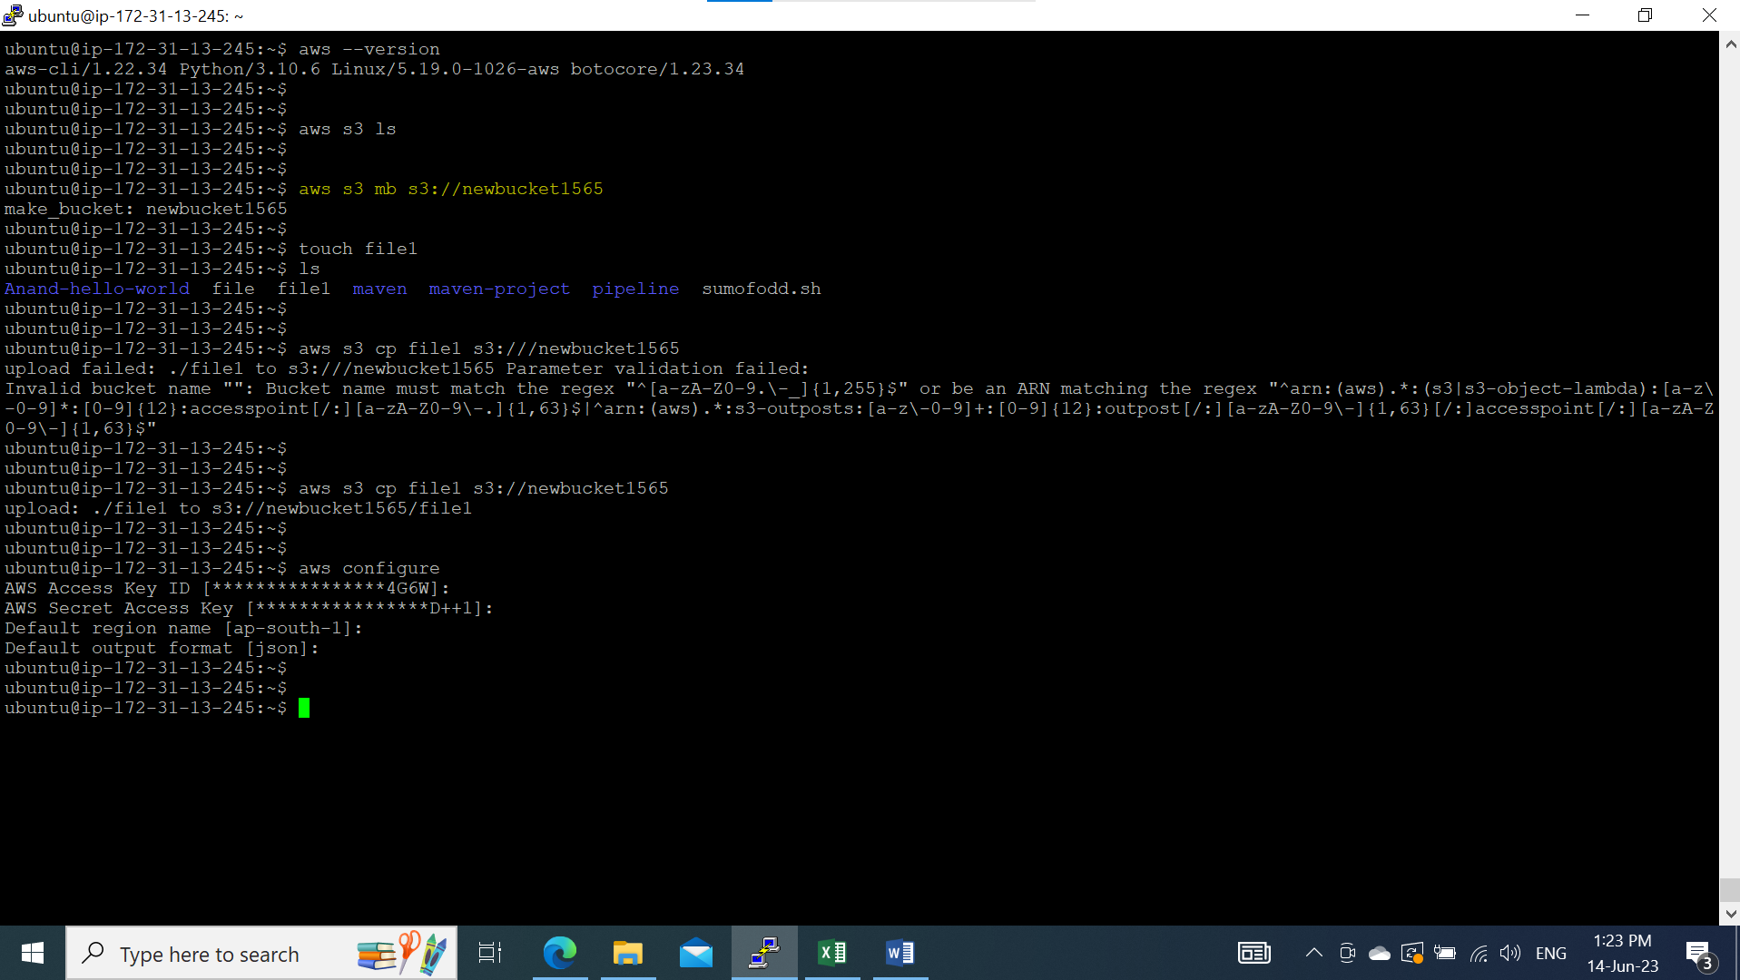

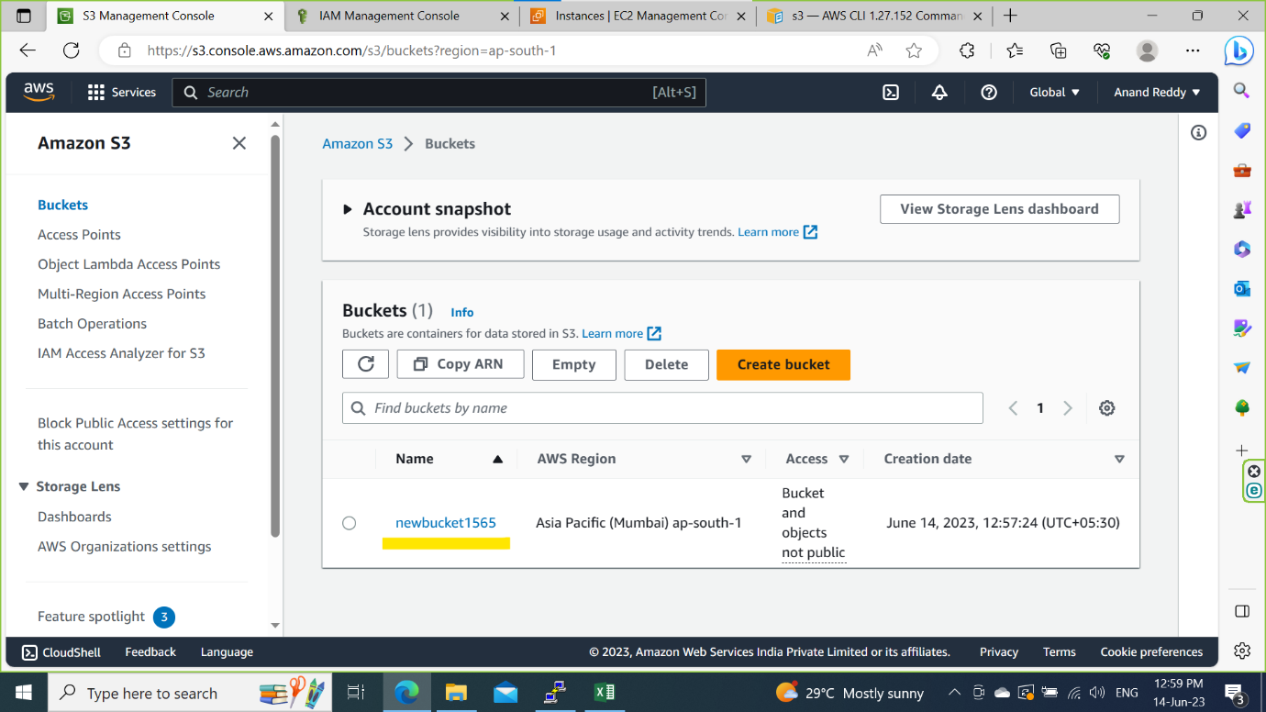

Step 2: Create a file in Ec2 instance and copy file to S3 bucket

Command: **aws s3 cp s3://<bucket_name>**

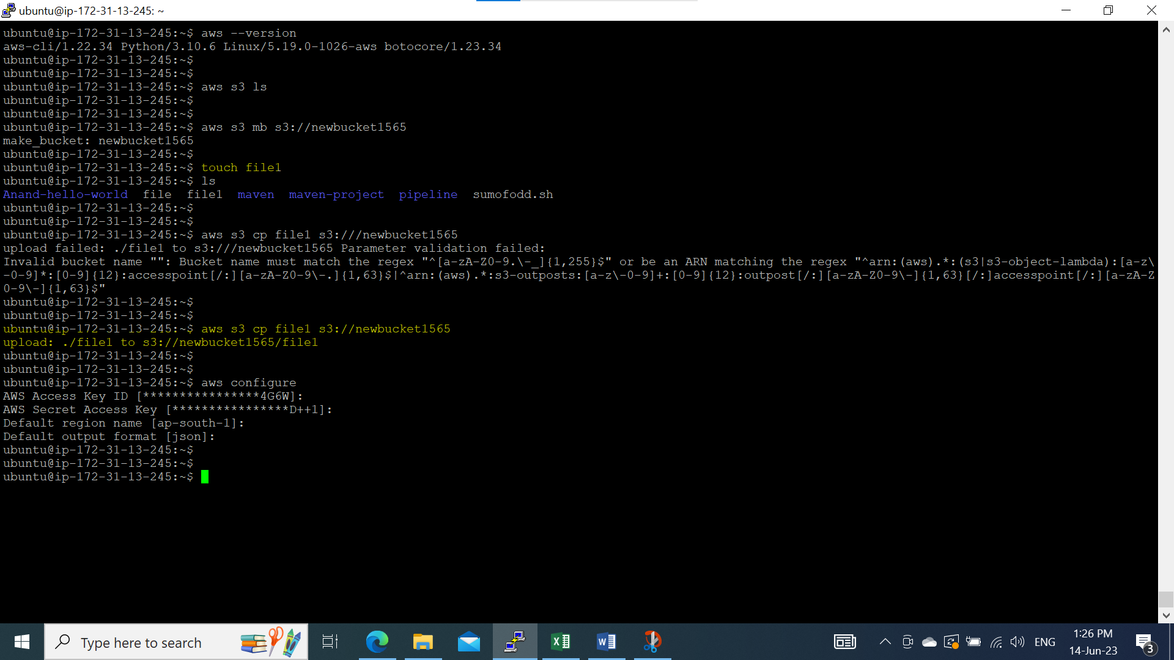

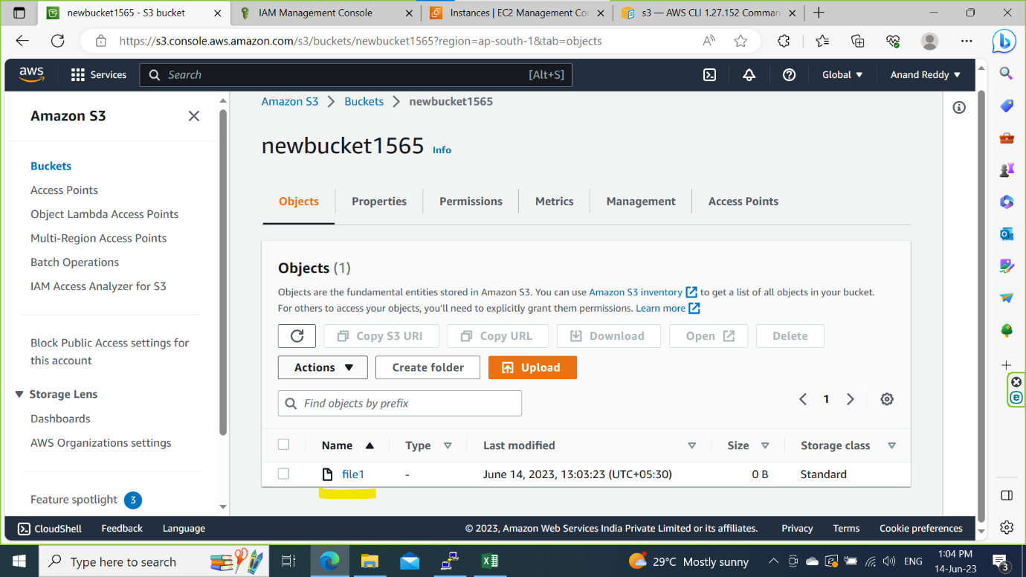

Step 3: using life cycle rules move a file to Glacier Archival storage class after one day.

Click on bucket and navigate Management and click on the life cycle rules

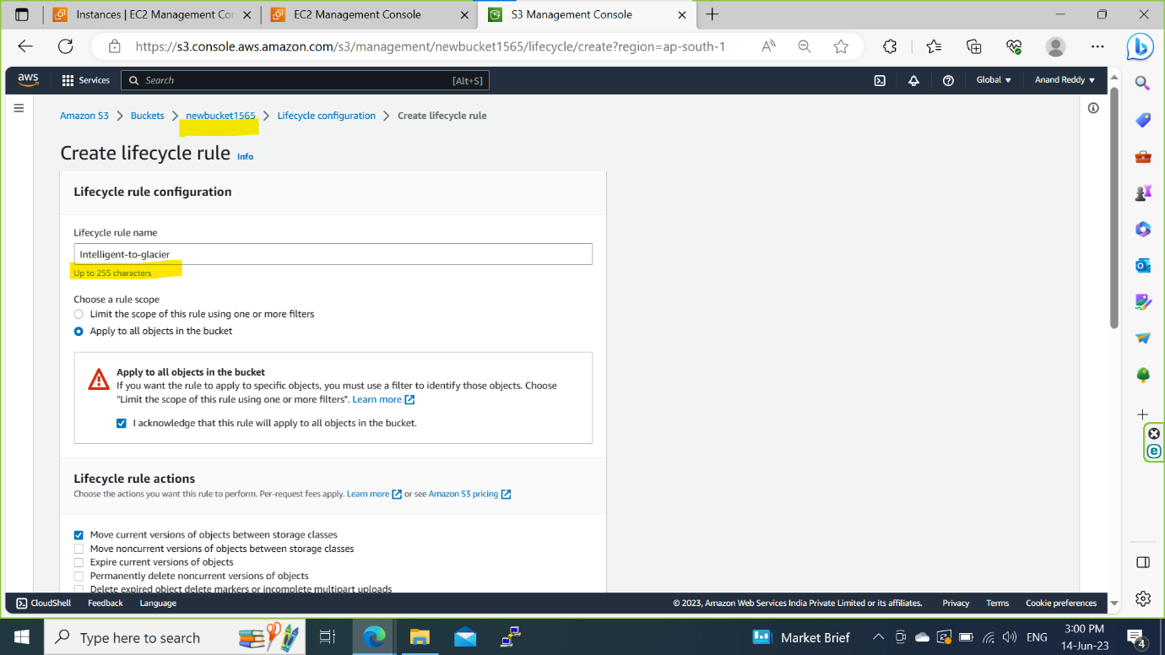

Step 4: Select the Glacier Archival and set the rule

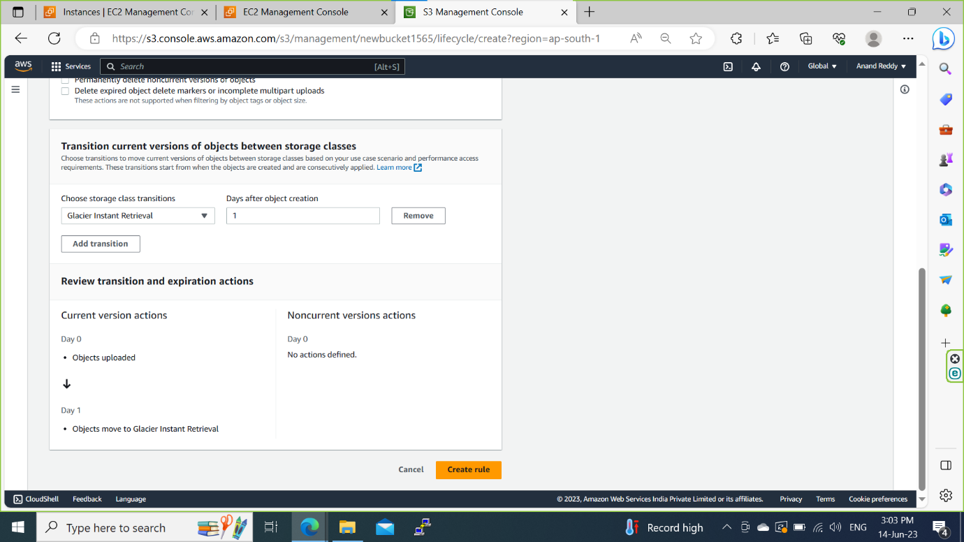

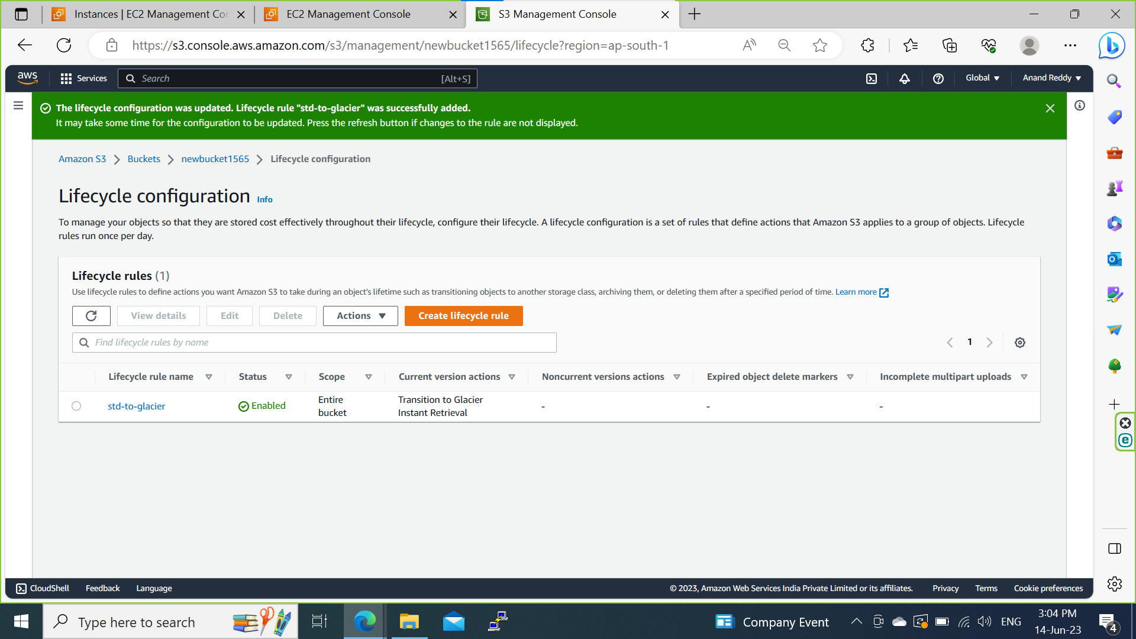

**Assignment 4:** Create a instance and create a EBS volume attach to instance and store a file and detach and attach to other instance and check the stored file.

Step 1: Create a 5gb volume and attach to the SPC instance

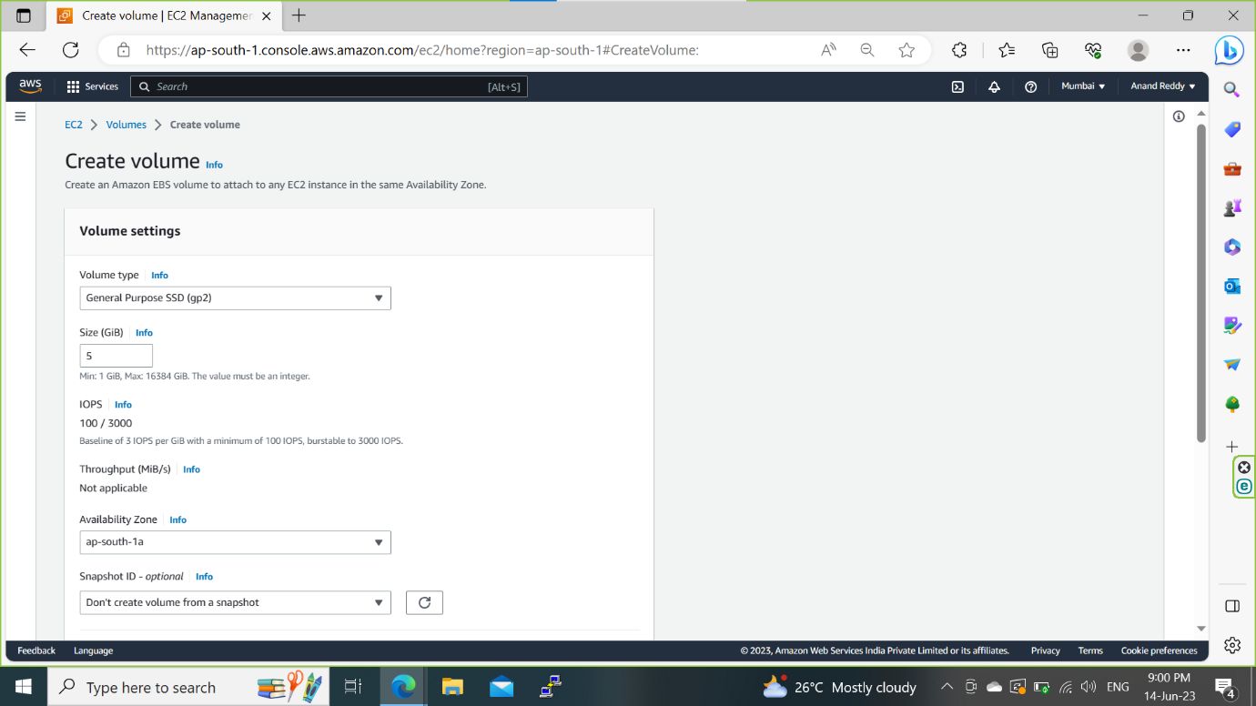

Created a 5gb volume

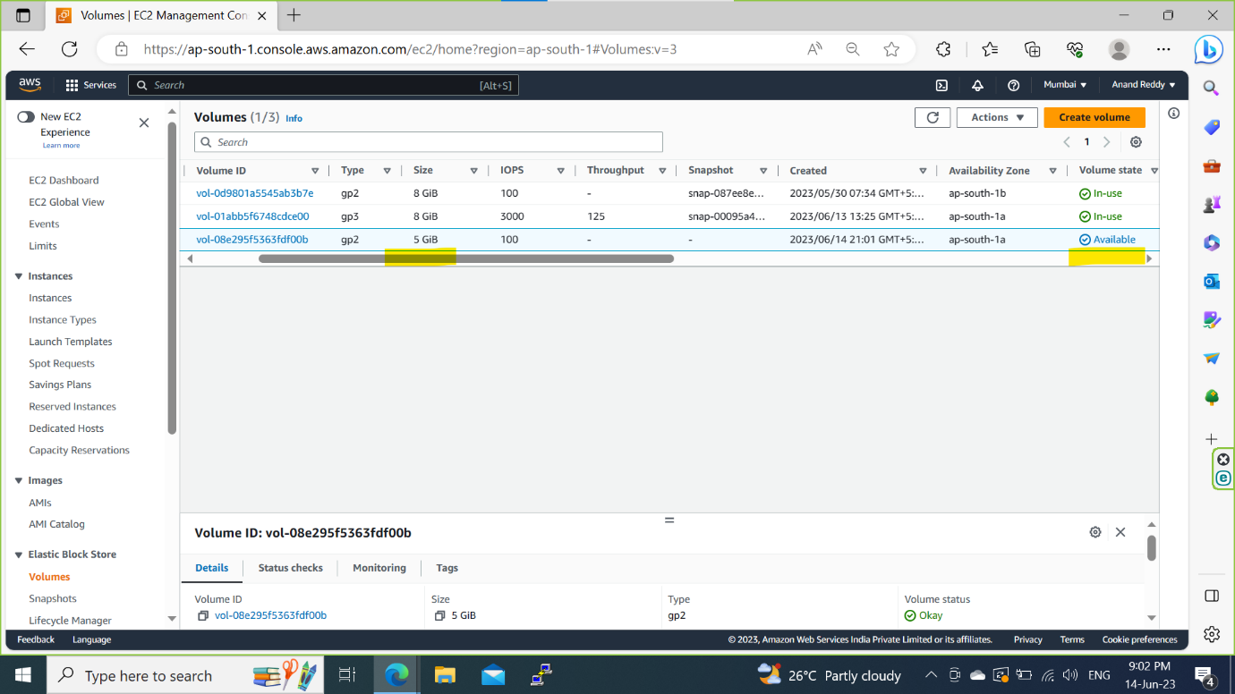

step 2: Attach the created volume to the SPC server

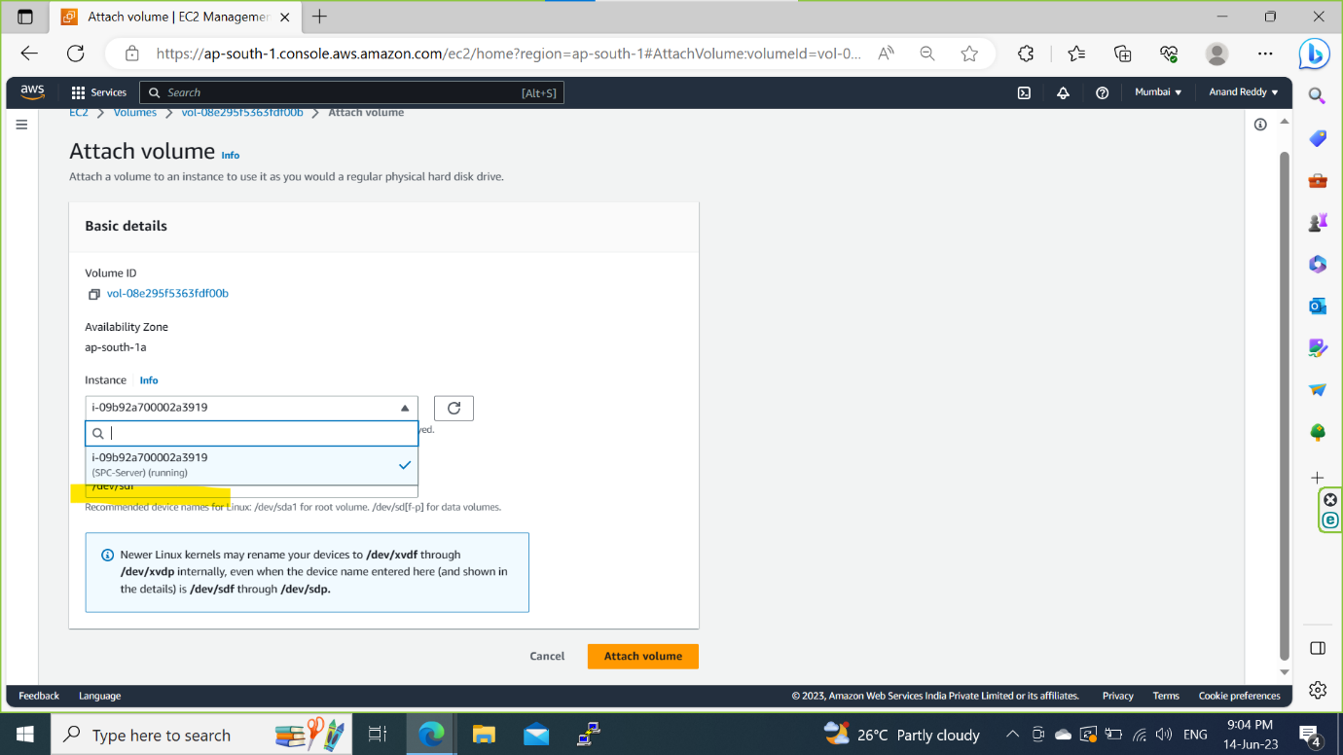

Step 3: Check whether the volume is attached to SPC server or not using putty

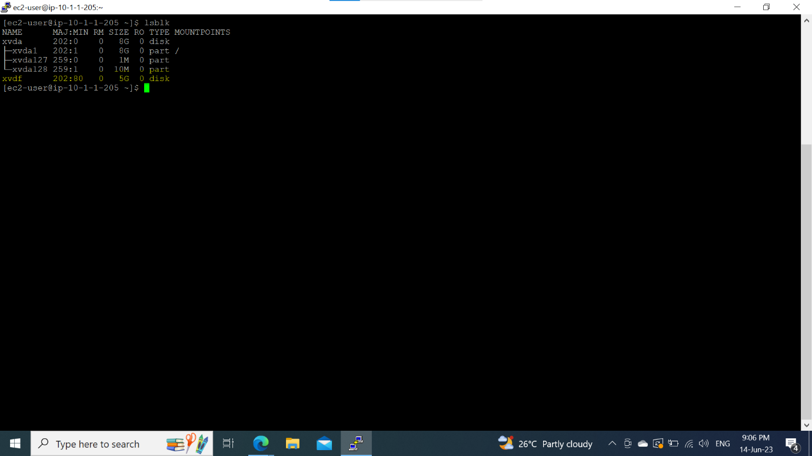

Step 4: Do partition of disk and make a file system and make a directory name it as 5gbdrive and mount to it and create a files.

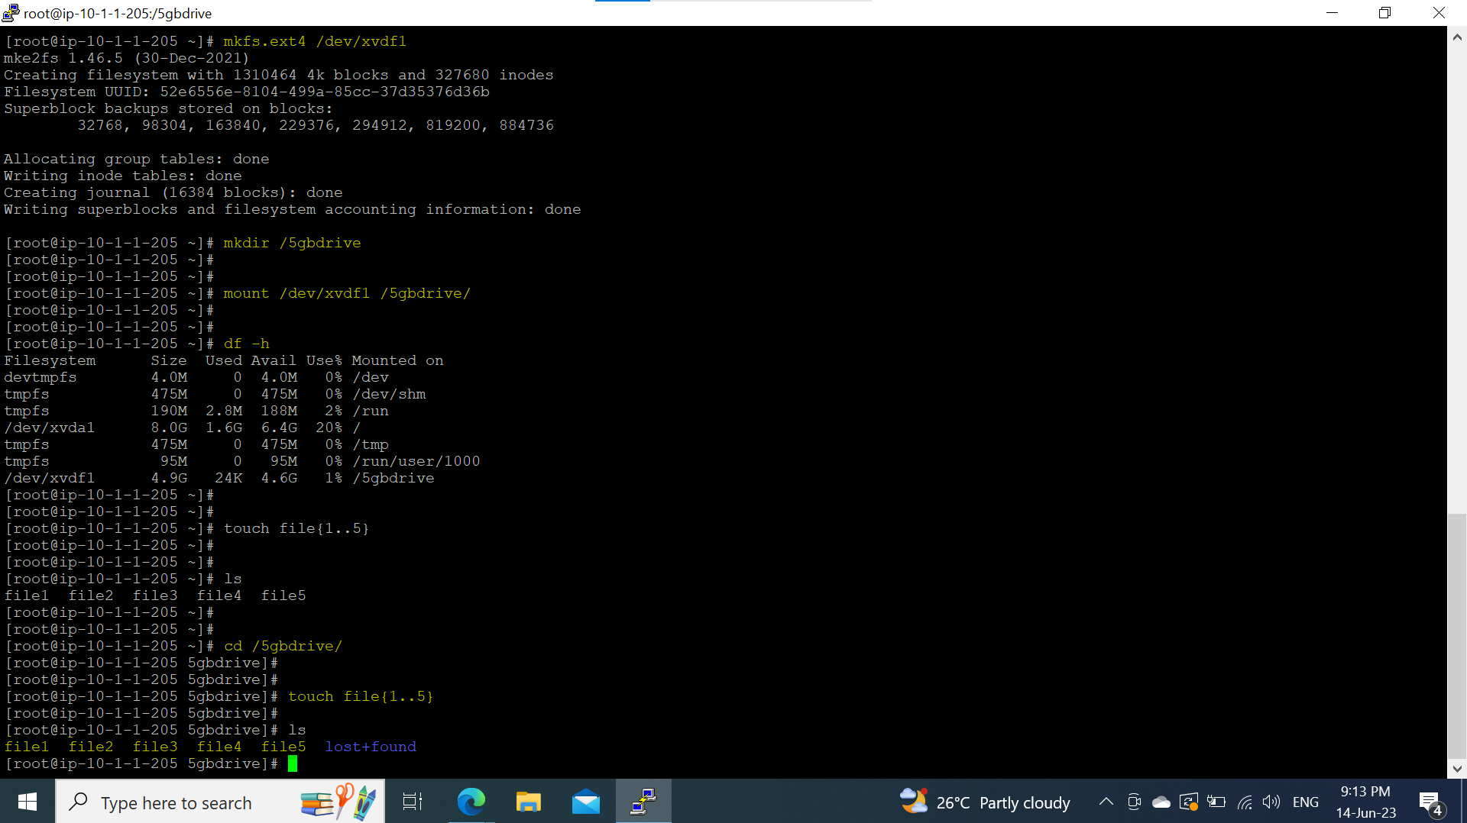

Step 5: unmount the volume

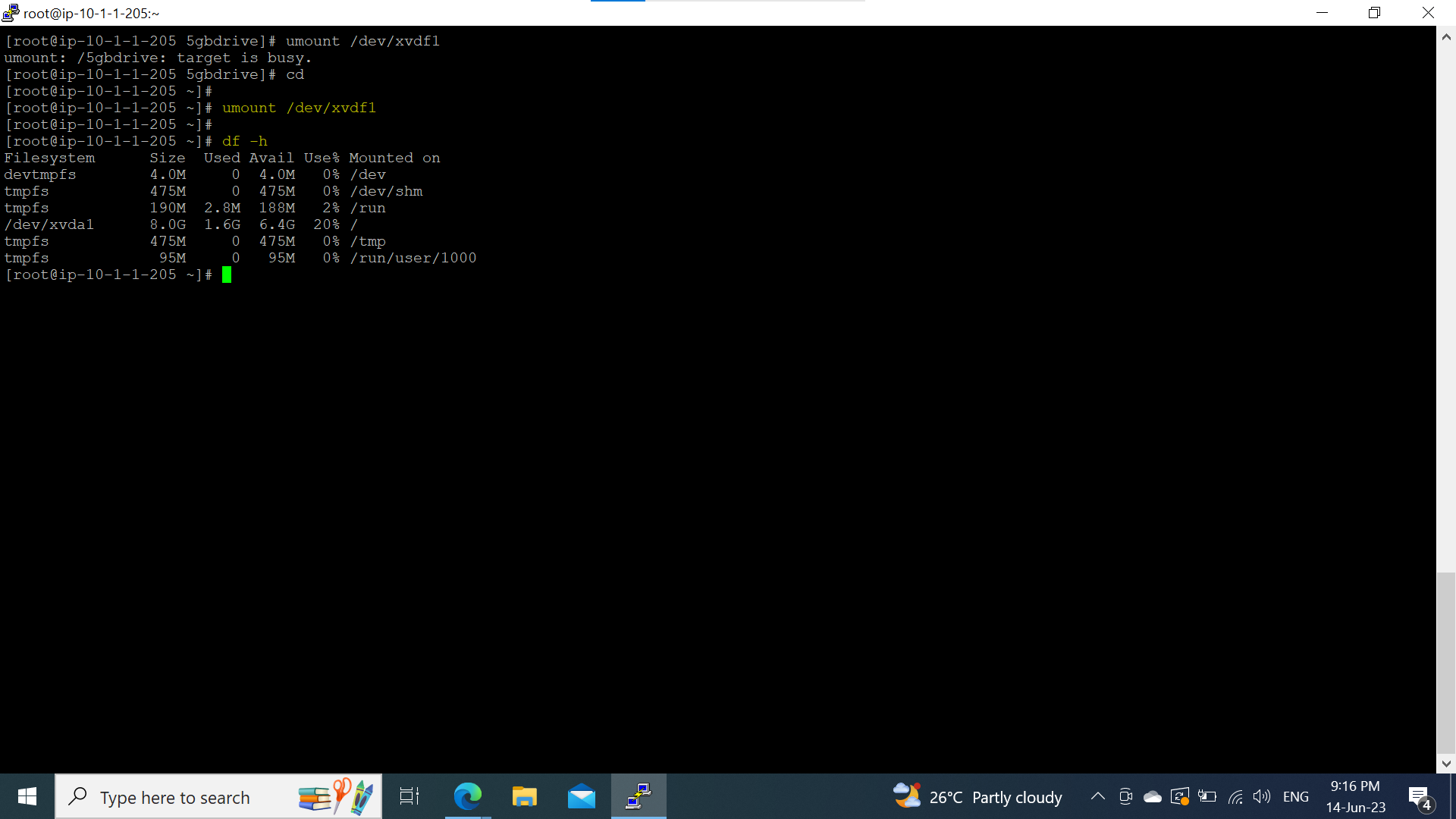

Step 6: detach the volume from the SPC server.

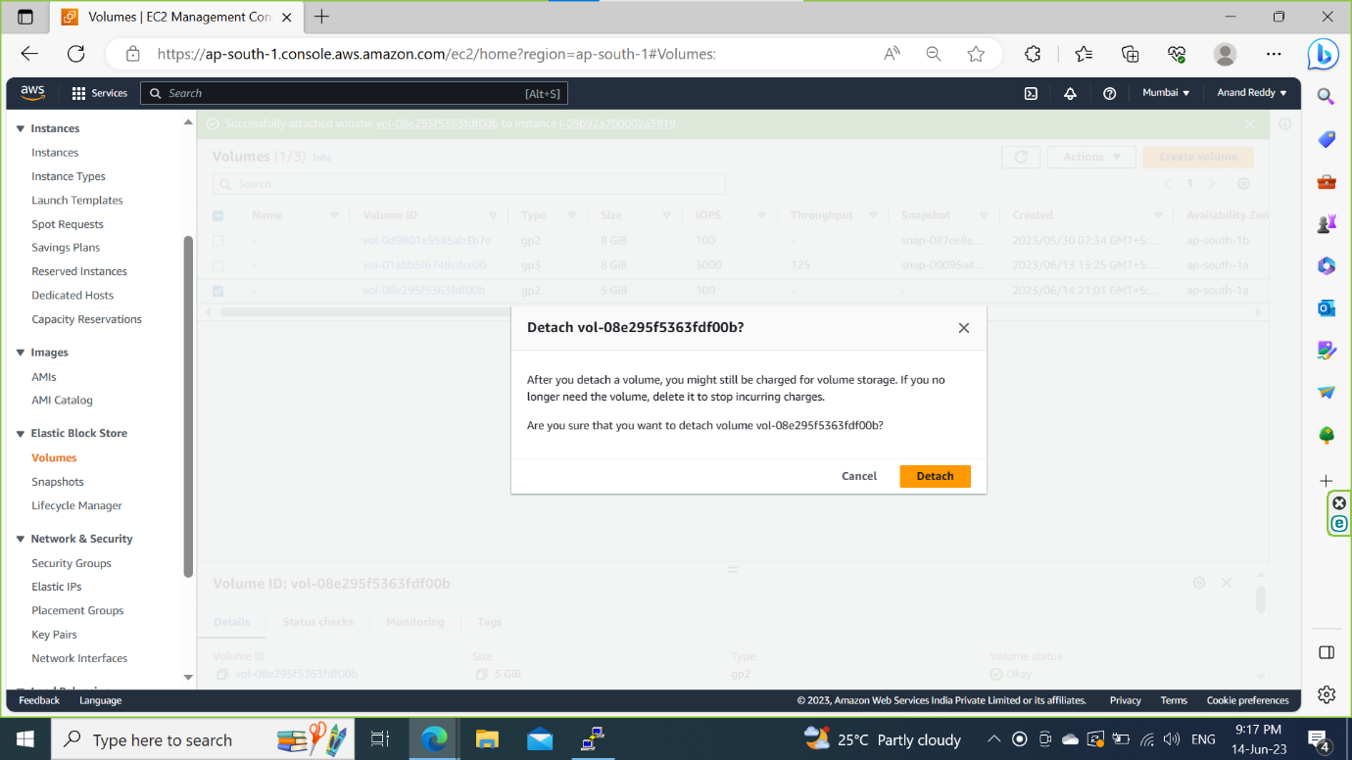

Step 7: Attach same volume to the another server name it as 2nd server

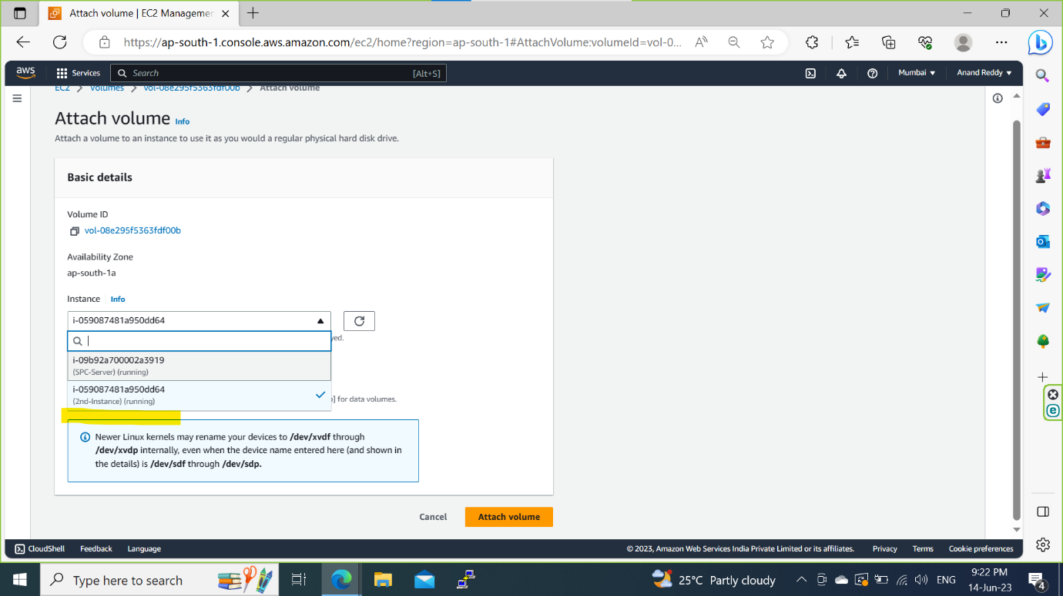

Step 8: Mount it to the 2nd server and check whether files are saved or not.

